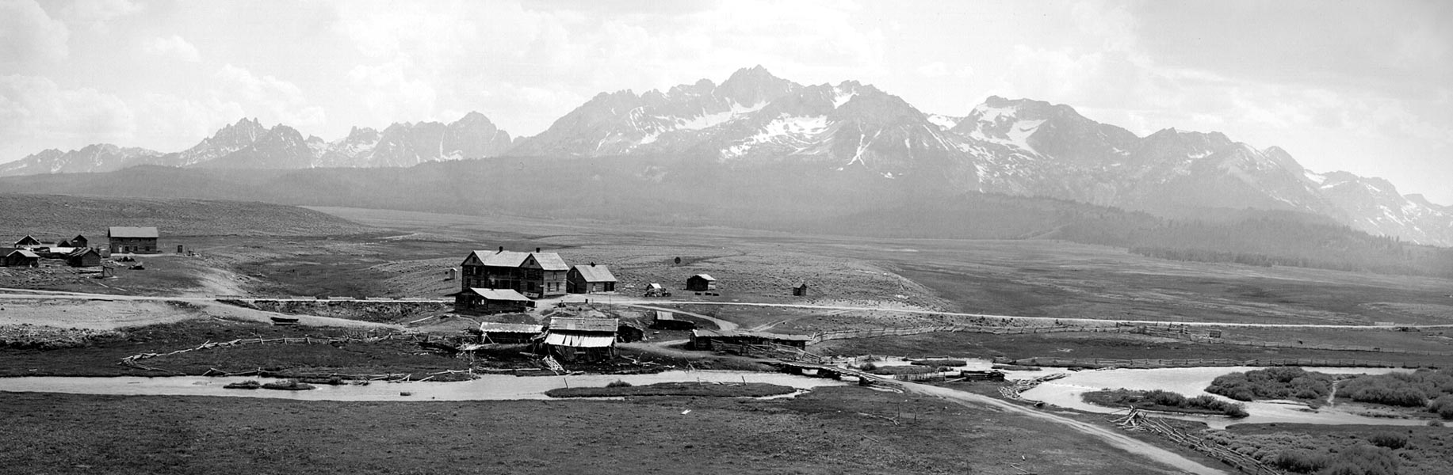

City of Stanley

**City Council Meeting Agenda**

**November 14, 2024**

**5:30 p.m.**

Stanley Community Center, 510 Eva Falls Stanley, ID 83278

**Regular Council Meeting (Idaho Code 74-204 (1)**

**Call to Order:** (Mayor Botti)

**Roll Call:**

Agenda Amendments [Idaho Code 74-204 (4)(b) and (c)]:

Mayor Comments:

**Council Comments:**

**Presentations/Citizen Participation:**

The public is invited to present commentary at will regarding any city-related business, whether or not that item is included on the agenda. Comments are limited to five (5) minutes and may or may not be addressed by the Council/Mayor.

**Consent Agenda:**

* October 10 2024 Council Meeting Minutes, and the Payment approval – Unpaid and prepaid bills for October – Action item

**Law Enforcement:**

* Sheriff’s Reports
* Incident Reports

**Community Building:**

* Pancake Breakfast Dec 14
* December Pancake Breakfast—extending the time for a community Christmas Bazaar
  + Participants don’t have to pay a fee but will submit their option taxes; Kim will have a list of participants.

**Pioneer Park:**

**Streets and Roads**:

* Winter Streets and Roads contract has been sent to Stanley Construction, awaiting signatures

**Ad Hoc Committee Chairs:**

Cemetery: (Laurii Gadwa):

Code Review/Revision: (Steve Botti):

Sawtooth Association (SIHA): (Lin Gray):

Snowmobile Groomer: (Gary Gadwa): Winter ’24 grooming report, ’25 grooming season.

Chamber of Commerce: (Chamber Representative)

Report on current activities, advertising, events, etc.

**Old Business:**

* Jeff Welker’s requests for a $250 donation from the city for the Fat Bike Fondo for their 11th annual event scheduled February 02/22/25 thru 02/23/25. **Action Item**

**New Business**:

* Rivera/Clair Teepee -Action Item.
* Alpine enterprises record of survey request—Action Item
* Sawtooth Outdoor Bonspiel:Approve use of the ice rink Jan 24-26 2025—Action Item

**Building Permits approved by the Building Administrator:**

###### City Clerk Report:

* Update on City Office employees
* Update on search for new employees

**Option Tax/Treasury Report:**

* Option Tax update-FY24 option tax totals, Quarterly Survey of Non-Property Taxes FY24 Q4
* Requirements for end of year financial reporting requirements and where the City is with budgets and financial reports
* Update on auditor agreement for option tax funds—Mayor Botti
* Update on treasurer—Mayor Botti

**Adjournment:**