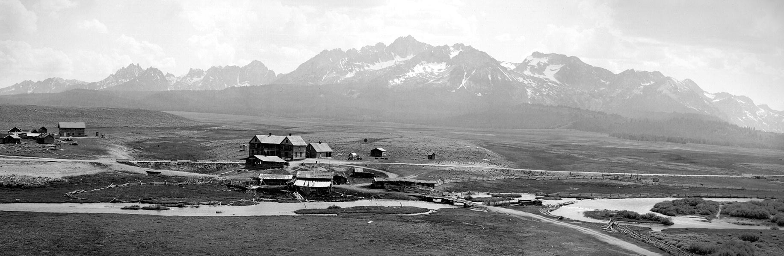

City of Stanley

**City Council Meeting Agenda**

**August 8, 2024**

**6:00 p.m.**

Stanley Community Center, 510 Eva Falls Stanley, ID 83278

**Regular Council Meeting (Idaho Code 74-204 (1)**

**Call to Order:** (Mayor Botti)

**Roll Call:**

Agenda Amendments [Idaho Code 74-204 (4)(b) and (c)]:

Mayor Comments:

**Council Comments:**

**Presentations/Citizen Participation:**

The public is invited to present commentary at will regarding any city-related business, whether or not that item is included on the agenda. Comments are limited to five (5) minutes and may or may not be addressed by the Council/Mayor.

**Consent Agenda:**

* July 11, 2024 Council Meeting Minutes, June, 6, 2024 Executive Session Minutes and the Payment approval – Unpaid and prepaid bills for June – Action item

**Law Enforcement:**

* Sheriff’s Reports
* Incident Reports

**Community Building:**

**Pioneer Park:**

**Streets and Roads**:



**Ad Hoc Committee Chairs:**

Cemetery: (Laurii Gadwa):

Code Review/Revision: (Steve Botti):

Sawtooth Association (SIHA): (Lin Gray):

Snowmobile Groomer: (Gary Gadwa):

Chamber of Commerce: (Chamber Representative)

Report on current activities, advertising, events, etc.

**Old Business:**

* Continued refinement of fy2025 Budget—Action item

**New Business**:

* None

**Building Permits approved by the Building Administrator:**

* Building Permit Application: Clair/Rivera—Action Item.

###### City Clerk Report: (Jennifer Hayes)

**Option Tax/Treasury Report:**

* Option Tax update
* Budget Workshop Dates—

**Adjournment:**

**Join via Zoom:**

**City Clerk is inviting you to a scheduled Zoom meeting.**

**Topic: August City Council Meeting**

**Time: Aug 8, 2024 06:00 PM Mountain Time (US and Canada)**

**Join Zoom Meeting**

**https://us02web.zoom.us/j/81237031476?pwd=iukzMtEAniDdJgbZW5YhqJKjuRaBaV.1**

**Meeting ID: 812 3703 1476**

**Passcode: 939918**

**Find your local number: https://us02web.zoom.us/u/kb3iAMPHbp**