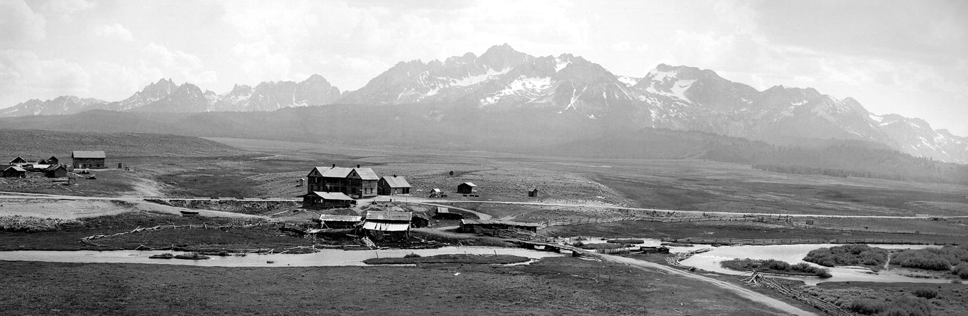

City of Stanley

City Council Meeting Agenda
January 19, 2024
4:00 p.m.

Call to Order: (Mayor Botti)

Roll Call:

EXECUTIVE SESSION:
- Executive Session 74-206 (1) (A) (B): Personnel issues

Adjournment:

Council Meeting will start directly after the Executive Session:

Regular Council Meeting (Idaho Code 74-204 (1)

Call to Order: (Mayor Botti)

Roll Call:

Agenda Amendments [Idaho Code 74-204 (4)(b) and (c)]:

Mayor Comments:

Council Comments:

Presentations/Citizen Participation:
The public is invited to present commentary at will regarding any city-related business, whether or not that item is included on the agenda. Comments are limited to five (5) minutes and may or may not be addressed by the Council/Mayor.

Consent Agenda:
- October 5, 2023 Council Meeting, December 5, 2023 Council Meeting, December 8, 2023 Special Meeting, December 14, 2023 Council Meeting and the Payment approval – Unpaid and prepaid bills for December/January – action item

Installation of two City Council Seats – 4-year term:
- Administration of Oath of Offices - action item
- Presentation of Certificates of Election - action item
- Selection of Council President - action item

Law Enforcement:
- Sheriff’s Reports

Community Building:
- Sawtooth Outdoor Bonspiel would like to request use of the community Building January 26th thru January 27, 2024, waiving all rental fees, and paying a cleaning fee – action item
- Stanley School District is requesting use of the Community Building with all fees waived or reduced for the Boise Rock Summer Camp June 17th thru June 21st - action item

Pioneer Park:
- 2024 Pioneer Park Wedding request. The City Clerk already has a wedding scheduled for September 18, 2024, this wedding would be a week later, so therefore I need the city Council approval – action item

Streets and Roads:

Ad Hoc Committee Chairs:
Cemetery: (Laurii Gadwa)
Code Review/Revision: (Steve Botti):
Sawtooth Association (SIHA): (Lin Gray)
Snowmobile Groomer: (Gary Gadwa)
Chamber of Commerce: (Chamber Representative)
Report on current activities, advertising, events, etc.

Old Business:

New Business:
- Discuss whether or not to re-appoint the City Clerk Cari Tassano – action item
- Discuss whether or not to re-appoint the Treasurer Cari Tassano - action item

Building Permits/City Council Approval:
- none

Building Permits approved by the Building Administrator:
- none

City Clerk Report: (City Clerk/Treasurer Cari Tassano)
- City Clerk Priories for January 2024:
Alcohol Beverage Licenses
Working on 2023 Audit
Streets and Roads State report
State & Federal quarterly returns
State annual return
Treasury Report
Bike Fundo permit with SNRA
2 Hour webinar for W-2 in accounting system
Implementing Employees or Employee records. The city went from 3 employees to 18 Employees in the last 5 days.
Completed Covid-19 reporting with the Federal Treasury Department
Printed required checks due to the late council meeting date.
Ordered new Credit Card for the Groomer Fund
Submitted Quarterly Water Test
W-2’s
1099

Option Tax/Treasury Report: (City Clerk/Treasurer Cari Tassano)
Monthly Financials, Check Register, Accounts Receivable Report, Option Tax Report, Local Government Investment Pool.

Adjournment:

